**DAILY ONLINE ACTIVITIES SUMMARY**

|  |  |  |  |  |  |  |  |  |
| --- | --- | --- | --- | --- | --- | --- | --- | --- |
| **Date:** | **31-05-2020** | | | | | **Name:** | **Priyanka Killedar** | |
| **Sem & Sec** | **6th  Sem ‘B’ Sec** | | | | | **USN:** | **4AL17CS067** | |
| **Online Test Summary** | | | | | | | | |
| **Subject** | | **--** | | | | | | |
| **Max. Marks** | | **--** | | **Score** | | | **--** | |
| **Certification Course Summary** | | | | | | | | |
| **Course** | Blockchain Essentials [Start Course](https://courses.cognitiveclass.ai/courses/course-v1:developerWorks+BC0101EN+v1/jump_to/block-v1:developerWorks+BC0101EN+v1+type@course+block@course) | | | | | | | |
| **Certificate Provider** | | | **IBM** | | **Duration** | | | **6 hr** |
| **Coding Challenges** | | | | | | | | |
| **Problem Statement:1 program** | | | | | | | | |
| **Status: done** | | | | | | | | |
| **Uploaded the report in Github** | | | | | **yes** | | | |
| **If yes Repository name** | | | | | <https://github.com/Priya-s-k/Online-coding-updates> | | | |
| **Uploaded the report in slack** | | | | | **yes** | | | |

**Certification Course Details:**

**Today Progress:**

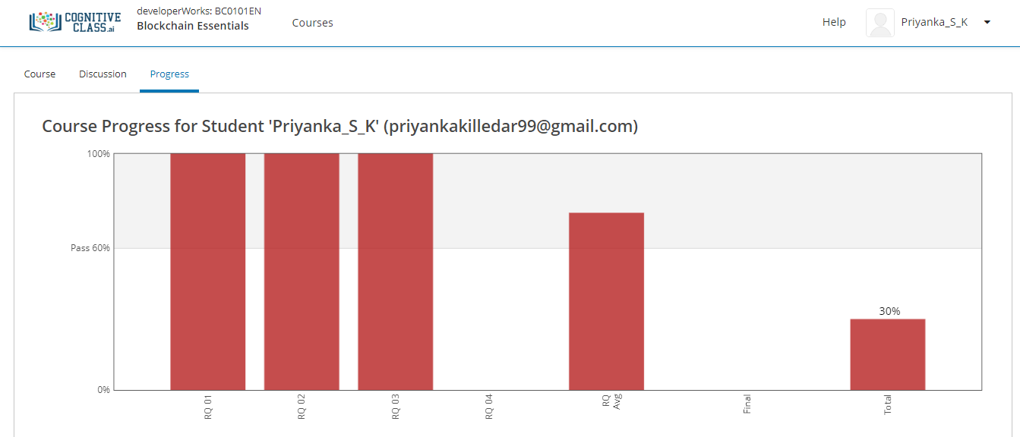

I solved the review question on module 3 and above screenshot is the progress of 3rd module .

**Coding Challenges Details:**

Refer the github link for detail information :<https://github.com/Priya-s-k/Online-coding-updates>

Solved all the problems and the solutions are uploaded in github account.

The same report is also available in github: <https://github.com/Priya-s-k/online-activity-updates>